**IBM Applied Data Science Capstone Project Report**

**Predicting Road Accident Severity   
  
By: Ritvik Shyam**

**Word Count: 2271**

1. **Introduction/Business Problem**

The introduction and business problem which defines this project is to create a predictive machine learning model intended for car drivers to enable the reduction in frequency of car collisions through the implementation of algorithms that predict the severity of an accident. The functional aim of the model is to alert the car driver to be cautious about safety if and when the conditions listed above are unfavourable by analysing a significant range of factors including weather conditions, public events, road-works and traffic congestions.

The tangible outcome of this project is to utilize its insights and findings to enable relevant stakeholders such as law enforcement and private companies involved in road contracts to allocate their resources more effectively in advance to prevent potential accidents, thus significantly saving resources and alerting drivers accurately in order to save thousands of human lives.

1. **Data**

**2.1 Original dataset features**

The source of the data is the following [Kaggle data set](https://www.kaggle.com/ahmedlahlou/accidents-in-france-from-2005-to-2016) consisting of all the recorded accidents in France from 2005 to 2016, divided in 5 different data sets which share the accident identifications number. The characteristics data set contains information on the time, place, and type of collision, weather and lighting conditions and type of intersection where it occurred. The places data set has the road specifics such as the gradient, shape and category of the road, the traffic regime, surface conditions and infrastructure. On the other hand, the user data set contains the place occupied by the users of the vehicle, information on the users involved in the accident, reason of traveling, severity of the accident, the use of safety equipment and information on the pedestrians. The vehicle data set contains the flow and type of vehicle, and the holiday one labels the accidents occurring in a holiday.

In order to decrease the size of the dataset and prevent redundancy, initial data analysis was performed in order to select the most relevant features for this project. With this process the number of features was reduced from 54 to 28.

**2.2 Refined dataset features**

The dataset that resulted from the feature selection consisted in 839,985 samples, each one describing an accident and 29 different features.

From the characteristics dataset: lighting, localization, type of intersection, atmospheric conditions, type of collisions, department, time and the coordinates which are described in the Kaggle dataset here. In addition, two new features were crafted, date to perform a seasonality analysis of the accident severity and weekend indicating whether the accident occurred during the weekend. Regarding the places dataset, the selected features where: road category, traffic regime, number of traffic lanes, road profile, road shape, surface condition, situation, school nearby and infrastructure.

The users dataset was used to craft some new features:

• number of users: total number of people involved in the accident.

• pedestrians: whether there were pedestrians involved (1) or not (0).

• critical age: whether there were users between 17 or 31 years old involved in the accident.

• severity : maximum gravity suffered by any user involved in the accident. Unscathed or light injury (0), hospitalized wounded or death (1)

The holiday dataset was used to add a last feature, labelling the accidents which occurred in a holiday.

**2.3 Data cleaning and formatting**

The data cleaning is the process of giving a proper format to the data for its further analysis. The first step was to deal with missing values and outliers. Initially the latitude, longitude and road number were dropped form the data 3 frame as more than a 50% of its values where ‘NaN’ or 0 which is an outlier in this case. Then keeping with replacing the missing values, the analysis was divided in two groups of features. The first group had in all features a label which described other cases, for instance the feature describing the atmospheric conditions had a value of 9 for any other atmospheric condition not labelled with the other 8 values. Therefore, the missing values and outliers were replaced with the other cases label for the features of atmospheric conditions, type of collision, road category and the surface conditions. For the second group of features instead, the distribution of their values was analysed, following which the infrastructures and reserved lanes features were dropped alongside other outliers representing more than 75% of its data.

Finally with the rest of the features with missing values, the traffic regime, the number of lanes, the road profile and shape and the situation at the time of the accident, the NaN and outliers were replaced with the feature’s most popular value. Last format changes were performed to the school and department values. The school feature had all samples divided either in the 0 or the 100 values, thus all the 100 values were replaced with a 1. Similarly the department feature had an extra 0 added at the units position, so all values were divided by 10.

Regarding the type of the data, all features had a coherent data type except for the date feature which was defined with the string type. The ‘to data’ function of pandas was used to define the date feature with the datetime type. The result was that 24 features remained.

# 3 Exploratory Data Analysis

The visulation of the plot confirmed that it is a balanced labeled dataset as the samples are divided 56-54 with more cases of lower severity, following which a seasonality analysis was performed, visualizing the global trend of daily accidents as well as the amount of accidents grouped by years, month of the year, and day of the week.

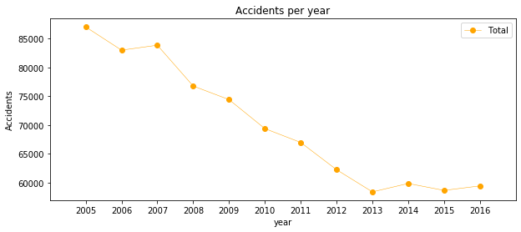

**Figure 1: Lineplot displaying the total amount of accidents annually.**

The previous image show that the number of traffic accidents decreased over the years from 2005 to 2013, after which the trend became stable. Analyzing the yearly trend there is a seasonal pattern where the number of accidents increase around March and then again in September. This pattern can be seen in following two figures.

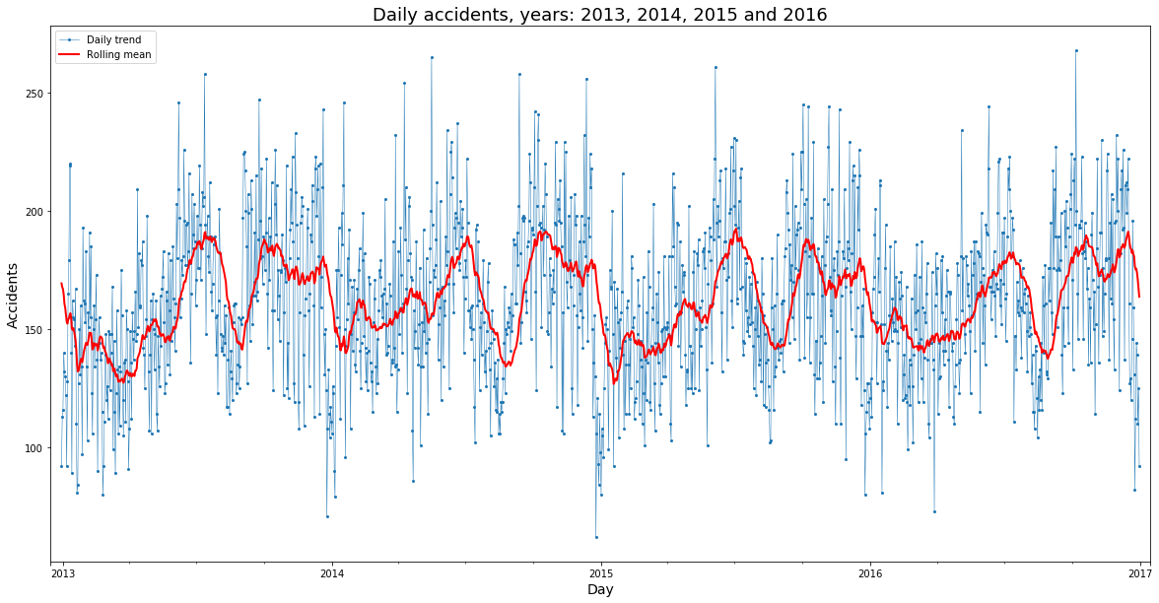

**Figure 2: Lineplot displayng the amount of accident per day during 2013, 2014, 2015 and 2016. The plot includes the rolling mean, with a window size of 30 days.**

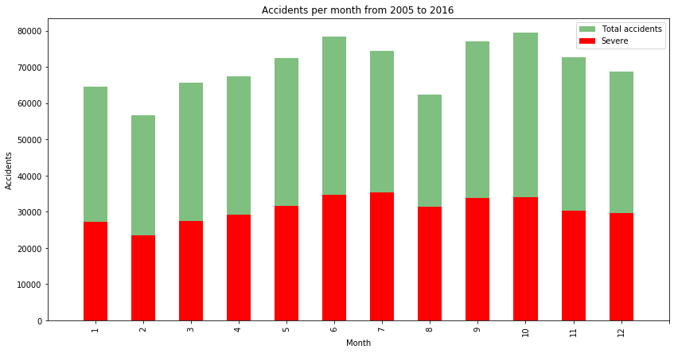

**Figure 3: Barplot: Amount of accident per month between 2005 and 2016.**

Regarding the day of the week there is not a significant difference between them, **Figure 4**. There is a steady trend during the week with more accidents on Friday, and Sunday is the day with less recorded accident of all.

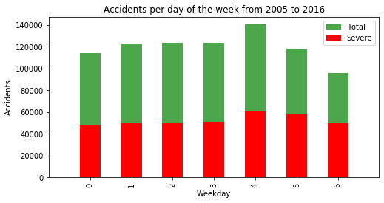

**Figure 4: Barplot displaying the accident rate per day of the week from 2005 to 2016.**

Lastly analyzing the accidents per hour, there are clearly two spikes, one at 8am, the time people go to work and another one between 5 and 6pm, time when people return home. The number of accidents decreases between these two spikes, nothing unusual but it proves there is a pattern here.

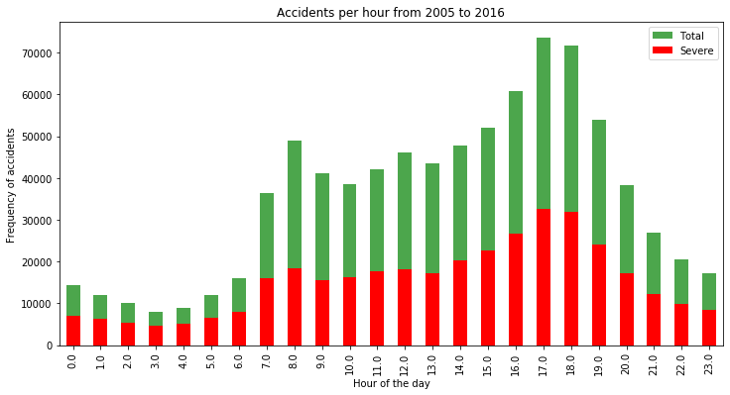

**Figure 5: Lineplot depicting the total amount of accidents annually.**

The trend of highly severe accidents is proportional to the global trend, for both the accidents divided per month of the year and per day of the week. Same thing happens with the amount of highly severe accidents by hour of the day as we can see on Figure5. One aspect to highlight from the hourly trend is that the proportion of severe accidents from noon to morning is higher, to be precise, the percentage of severe accidents from 9pm to 6am is 50.67% of the total amount of accidents occurring between these hours, while from 7am to 8pm is 42.41%. Due to the results of the former analysis, to features were added; month and day as the day of the month.

The next statistical analysis was the correlation of the features with the severity of an accident. The Pearson correlation showed weak or null correlation with all features. Further visualizations were performed for a better understanding of the data. Some conclusions of this analysis were for instance that accidents involving people above 84 years old tend to have a high severity.

# 4 Predictive Modelling

Different classification algorithms have been tuned and built for the prediction of the level of accident severity. These algorithms provided a supervised learning approach predicting with certain accuracy and computational time. These two properties have been compared in order to determine the best suited algorithm for his specific problem.

Firstly, the 839.985 rows where split 80/20 between the training and test sets, afterwards an additional 80/20 split was performed among the training samples creating the validation set for the development of the models. Then the data was standardized giving zero mean and unit variance to all features.

Four different approaches were used:

* Decision Tree (also Random Forest)
* Logistic Regression
* K-Nearest Neighbour
* Supervised Vector Machine

The same *modus operandi* was performed with each algorithm. With the train and validation sets the best hyperparameters were selected and using the test set the accuracy and computational time for the development of the models were calculated.

The decision tree model was upgraded to the random forest. With the default random forest the features were sorted by impurity based importance in the prediction of the severity. Thus, the 10 least important features were dropped to decrease the computation complexity for the **KNN** and **SVM** models. Keeping with 13 features the accuracy stayed the same and the computational time decreased significantly. After evaluating the parameters for each algorithm these were the models.

* Random Forest: 10 decision trees, maximum depth of 12 features and maximum of 8 features compared for the split.
* Logistic Regression: c=0.001.
* KNN: k=16
* SVM: size of the training set= 75,000 samples.

The following visualizations show how the parameters for KNN and SVM models were selected. The **SVM** model is computationally inefficient with huge sample sets. Therefore, an equilibrium between accuracy and computational time was a found evaluating different training sizes. The training set was reduced from 537,590 to 75,000 rows. On **Figure:**7, the accuracy is increasing as the training size does, however **Figure:**9 shows how this comes with an important increasing of the computational time.

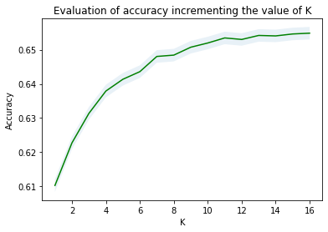

**Figure 6: Accuracy of KNN models increasing the value of K.**

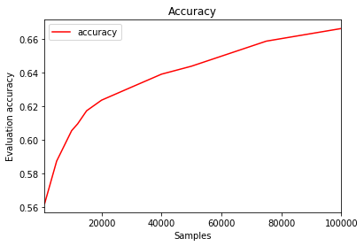

**Figure 7: Accuracy of SVM increasing the training sample’s size.**

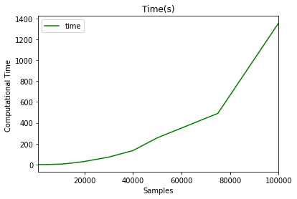

**Figure 8: Computational time of SVM increasing the training sample’s size.**

# 5 Results

The metrics used to compare the accuracy of the models are the *Jaccard Score*, *f1-score*, *Precision*[1] and *Recall*[2]. This table reports the results of the evaluation of each model.

## Algorithm Jaccard f1-score Precision Recall Time(s)

|  |  |  |  |  |  |
| --- | --- | --- | --- | --- | --- |
| **Random Forest** | 0.722 | 0.72 | 0.724 | 0.591 | 6.588 |
| **Logistic Regression** | 0.661 | 0.65 | 0.667 | 0.456 | 6.530 |
| **KNN** | 0.664 | 0.66 | 0.652 | 0.506 | 200.58 |
| **SVM** | 0.659 | 0.65 | 0.630 | 0.528 | 403.92 |

In this case, the recall is more important than the precision as a high recall will favor that all required resources will be equipped up to the severity of the accident. The *logistic regression*, *KNN*, and *SVM* models have similar accuracy, however the computational time from the regression is far better than the other two models. With no doubt the *Random Forest* is the best model, in the same time as the *log. res.* it improves the accuracy from 0.66 to 0.72 and the recall from 0.45 to 0.59.

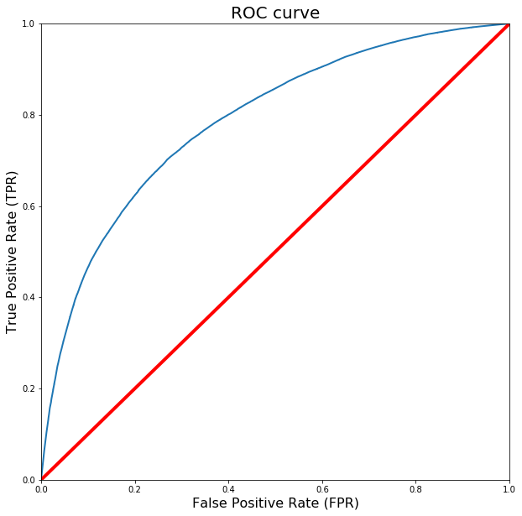

**Figure 9: Rempresentation of the ROC curve from the results of the Random Forest model.**

The best model was evaluated using their ROC curves. In this particular problem, lower false positive rate is less important than higher true positive rate. In other words, it is more important to properly predict the high-severity accidents properly, if there is room for doubt it is better to prevent.

# 6 Conclusion

The project involved the analysis of the relationship between severity of an accident and some characteristics which describe the situation that involved the accident. Initially I thought that features such as atmospheric conditions, the lighting or being a holiday would be the most relevant ones, yet I identified the department, the day and time of the accident, the road category and type of collision among the most important features that affect to the gravity of the accident. I built and compared 4 different classification models to predict whether an accident would have a high or low severity. These models can have multiple application in real life. For instance, imagine that emergency services have a application with some default features such as date, time and department/municipality and then with the information given by the witness calling to inform on the accident they could predict the severity of the accident before getting there and so alert nearby hospitals and prepare with the necessary equipment and staff. Also by identifying the features that favor the most the gravity of an accident, these could be tackled by improving road conditions or increasing the awareness of the population.

# 7 Observation

Overall accuracy in this case was 68%. However, there was still significant variance that could not be predicted by the models in this study, possibly due to influence of other features such as speed and uninterrupted time of traveling which could be used to predict a more accurate classification. Given the exponential rate of technological advancement, it is probable that cars will be able of track these feautures too so that the emergency services could use them.

Another constraint is the discrete, binary classification of the target classes (low and high severity). A continous labelling with a range from 0 to 100 would allow for the implementation of a regression model. Moreoever, a suitable extension would be to supplement an accident prediction model that predicts the critical time and spots where potential accidents can occur in advance, alongside the accuracy.

1. Proportion of predicted severe accidents that were truly severe
2. Proportion of truly severe accidents that were properly predicted